Process Management

1.What are the activites of the operating system in regard to process managemnet.
Ans: The five major activities are:
a. The creation and deletion of both user and system processes
b. The suspension and resumption of processes
c. The provision of mechanisms for process synchronization
d. The provision of mechanisms for process communication
e. The provision of mechanisms for deadlock handling

2.Process State.
Ans: Processes can be any of the following states :
- New - The process is in the stage of being created.
- Ready - The process has all the resources available that it needs to run, but the CPU is not currently working on this process's instructions.
- Running - The CPU is working on this process's instructions.
- Waiting - The process cannot run at the moment, because it is waiting for some resource to become available or for some event to occur.
- Terminated - The process has completed
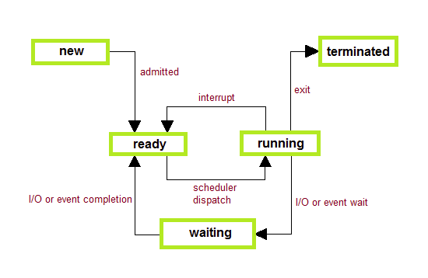

3.Why do we need scheduling?
Ans:
The act of determining which process in the ready state should be moved to the running state is known as Process Scheduling.
The prime aim of the process scheduling system is to keep the CPU busy all the time and to deliver minimum response time for all programs. For achieving this, the scheduler must apply appropriate rules for swapping processes IN and OUT of CPU.
Schedulers fell into one of the two general categories :
- Non pre-emptive scheduling. When the currently executing process gives up the CPU voluntarily.
- Pre-emptive scheduling. When the operating system decides to favour another process, pre-empting the currently executing process

4.Different Scheduling Algorithms?
Ans:
- First Come First Serve(FCFS) Scheduling
- Shortest-Job-First(SJF) Scheduling
- Priority Scheduling
- Round Robin(RR) Scheduling
- Multilevel Queue Scheduling

5.Operations on Process?
Ans:
Process creation: A user requests, and already running process can creates new processes. Parent process creates children processes using a system call, which, in turn create other processes, forming a tree of processes.
- Process preempting: A process preempted if I/O event or timeout occurs. Then process moves from running state to ready state and CPU loads another process from ready state to running state, if available.
- Process blocking: When a process needs I/O event during its execution, then process moves from running state to waiting state and dispatches another process to CPU.
- Process termination: A process terminated if when a process completes its execution. Also, these events: OS, Hardware interrupt, and Software interrupt can cause termination of a process.

File System Management
1.What are the activites of the operating system in regard to File system managemnet.
Ans: The five main major activities of an operating system in regard to file management are
1. The creation and deletion of files.
2. The creation and deletion of directions.
3. The support of primitives for manipulating files and directions.
4. The mapping of files onto secondary storage.
5. The back up of files on stable storage media

2.Explain about Sequential file access method?
Ans: The way that files are accessed and read into memory is determined by Access methods. Usually a single access method is supported by systems while there are OS's that support multiple access methods.
Sequential Access
- Data is accessed one record right after another is an order.
- Read command cause a pointer to be moved ahead by one.
- Write command allocate space for the record and move the pointer to the new End Of File.
- Such a method is reasonable for tape.
Direct Access
- This method is useful for disks.
- The file is viewed as a numbered sequence of blocks or records.
- There are no restrictions on which blocks are read/written, it can be dobe in any order.
- User now says "read n" rather than "read next".
- "n" is a number relative to the beginning of file, not relative to an absolute physical disk location.
Indexed Sequential Access
- It is built on top of Sequential access.
- It uses an Index to control the pointer while accessing files.

3.What is Mounting of file system?
Ans: Before you can access the files on a file system, you need to mount the file system. Mounting a file system attaches that file system to a directory (mount point) and makes it available to the system. The root (/) file system is always mounted. Any other file system can be connected or disconnected from the root (/) file system.
When you mount a file system, any files or directories in the underlying mount point directory are unavailable as long as the file system is mounted. These files are not permanently affected by the mounting process, and they become available again when the file system is unmounted. However, mount directories are typically empty, because you usually do not want to obscure existing files.

4.Explain about file control block?
Ans: A file control block (FCB), also called a file descriptor, is a type of data structure that is temporarily allocated by a computer operating system to maintain the status of a data file that is being created or otherwise manipulated. In most instances, a file control block is used to store basic information about a file, such as its name, extension and location on a logical drive, as well as dynamic information such as the current address within the file that is being read. Originally, a file control block was a very well-defined structure under certain operating systems, but it since has become a more generic term for the structure used to track information about an actively handled file.
One important purpose of a file control block is to help the file system keep track of what state the file is in to prevent different operations from attempting to modify the file in conflicting ways, such as reading from an area of the file that is currently being written to. The structure not only is used for data files, but also can be used to track information about directories, although the data structure usually is shortened to remove unnecessary fields, because a directory cannot contain dat

5.Explain about VFS
Ans:

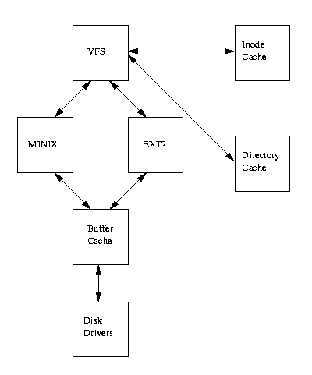
Virtual File System is an interface providing a clearly defined link between the operating system kernel and the different File Systems. The VFS supplies the applications with the system calls for file management (like “open”, “read”, “write” etc.), maintains internal data structures (the administrative data for maintaining the integrity of the File System), and passes tasks onto the appropriate actual File System. Another important job of the VFS is, performing standard actions. For example, as a rule, no File System implementation will actually provide an lseek() function, as the functions of lseek() are provided by a standard action of the VFS.

6.File system Formats
Ans:

File System Type | Description
ext | The first Linux filesystem used on early versions.
ext2 | The most featureful of the native Linux filesystems, but with no journaling support.
ext3 | The ext3 filesystem has all the features of the ext2 filesystem with journaling has been added.
swap | The Linux swap filesystem is associated with dedicated swap partitions.
reiserfs | A stable journaled filesystem.
Jfs | JFS is a journaled filesystem designed by IBM to to work in high performance environments
vfat | VFAT lets you read Windows 9x/NT/2000/XP/Vista partitions formatted to the FAT16 or FAT32 filesystems.
iso9660 | The standard filesystem for CD-ROMs
ntfs | The Microsoft Windows NT/2000/XP/2003/2008 filesystem designed for username/password security.
/proc | A Linux virtual filesystem. Virtual means that it doesn't occupy real disk space. Instead, files are created as needed. Used to provide information on kernel configuration and device status.
/dev/pts | The Linux implementation of the Open Group's Unix98 PTY support.
nfs | The Network File System, the system most commonly used to share files and printers between Linux and Unix computers.
cifs | The Common Internet File System (CIFS) is used to to share files and printers with Microsoft Windows operating systems.

7.Root file system
Ans: The root file system / is the parent of the entire file system. It is the first file system that is mounted when the kernel boots (unless you use an initial ramdisk), and your system will not function properly if the kernel detects corruption on this file system. Also, due to the nature of the boot process, this file system will eventually become writable (as the boot process needs to store its state information, etc.)
Some locations on the root file system are strongly advised to remain on the root file system (i.e. you should never ever mount another file system on top of that location). These locations are:
- /bin and /sbin as these contain the binaries (commands) or links to binaries that are needed to get a system up to the point it can mount other file systems. Although this functionality is gradually becoming less and less so, it would still break systems if you make separate mounts for these (small) locations.
- /lib as this contains the libraries that are needed by the commands in /bin.
- /etc as this contains the systems' configuration files, including those that are needed during the boot-up of the system.
A prime example of a configuration file inside /etc is fstab (which contains information about the other file systems to mount at boot time).
- https://www.centos.org/docs/5/html/Deployment_Guide-en-US/ch-filesystem.html

8.Swap Space
Ans: Swap space in Linux is used when the amount of physical memory (RAM) is full. If the system needs more memory resources and the RAM is full, inactive pages in memory are moved to the swap space. While swap space can help machines with a small amount of RAM, it should not be considered a replacement for more RAM. Swap space is located on hard drives, which have a slower access time than physical memory.
Swap space can be a dedicated swap partition (recommended), a swap file, or a combination of swap partitions and swap files.
Swap should equal 2x physical RAM for up to 2 GB of physical RAM, and then an additional 1x physical RAM for any amount above 2 GB, but never less than 32 MB.
So, if:
M = Amount of RAM in GB, and S = Amount of swap in GB, then
If M < 2
S = M *2
Else
S = M + 2
Using this formula, a system with 2 GB of physical RAM would have 4 GB of swap, while one with 3 GB of physical RAM would have 5 GB of swap. Creating a large swap space partition can be especially helpful if you plan to upgrade your RAM at a later time.
For systems with really large amounts of RAM (more than 32 GB) you can likely get away with a smaller swap partition (around 1x, or less, of physical RAM).
9.All about File system

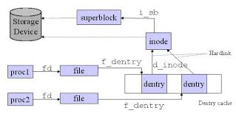

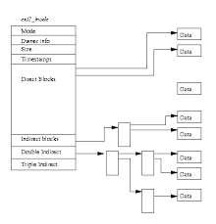

SuperBlock
The super block contains the following information
. the size of the file system.
This is the storage size of the device or current partition on the device.
. the list of storage blocks
The storage space is divided up into a series of standard size blocks.
When data is moved to or from the filesystem, it is moved in block units.
. the number of free blocks.
. the location of all free blocks.
. the index of the next free block in the free block list.
. the size of the inode list.
The inode list is initialized to track the maximum number of files
which cannot be more than the maximum number of strorage blocks.
. the number of free inodes in the file system.
. the index of the next free inode in the free inode list.

Inodes
The inode list is a static list. Once the filesystem is created, the size
of the list cannot change. The initial size of the inode list is determined
by the Administrator and the size of the storage device.

An inode for a file contains the following information.

File owner id.
(UID) This is the numeric id used in the password file to uniquely identify
a user on the system.

Group id.
(GID) This indentifies a group that can be granted special access by the
owner.

File type.
A file can be one of several filetypes. The following is a partial list.
- regular file - a file of data.
d directory file - a file that contains filenames and their associated inode
numbers.
l symbolic link file - a file that contains the path information needed to
access a file. Note that there is nothing to garentee that this information
is valid.
c character special file - a file that is to accessed one character at a time.
The keyboard of your terminal would be accessed as a character file.
b block special file - a file that is accessed a set number of bytes ( block )
at a time. The video screen on you pc is usually accessed as a block
special file device.
p pipe (fifo) - when connecting the output of a command to the input of
another, the system may need to buffer the data.

10.

